***Use this word document to describe all your steps after each problem. Show all commands & screen pages and describe your steps. Points are deducted for missing steps.***

Describe all steps for each problem set and capture screen shots for each step with a JPG image within this document. Do not forget to put your name on the top of this file for your submitted homework. Also, please replace _ALL_ text in red with your information!

**Problem 1:**

1. Download/Install ~~Jupiter~~ Jupyter Notebook on your computer;
2. Provide **all steps** of installing it, thinks about it as you are making a manual for someone who has no idea on how to do so;

**Total points: 35**

Put all your steps and screen captures here.

**Download/Install ~~Jupiter~~ Jupyter Notebook on your computer;**

To use the Jupyter Notebook, we have to download the Anaconda (a very handy data science toolkit platform) through the following link: <https://www.anaconda.com/>



(choose the individual edition)

Then click the download button ↓

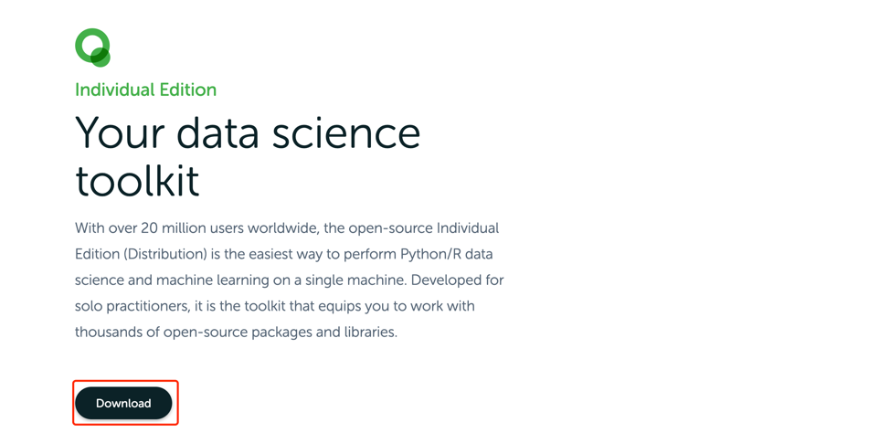

Choose the appropriate version for your PC, I personally use MacOS so I downloaded Python 3.7 64-Bit Graphical Installer ↓

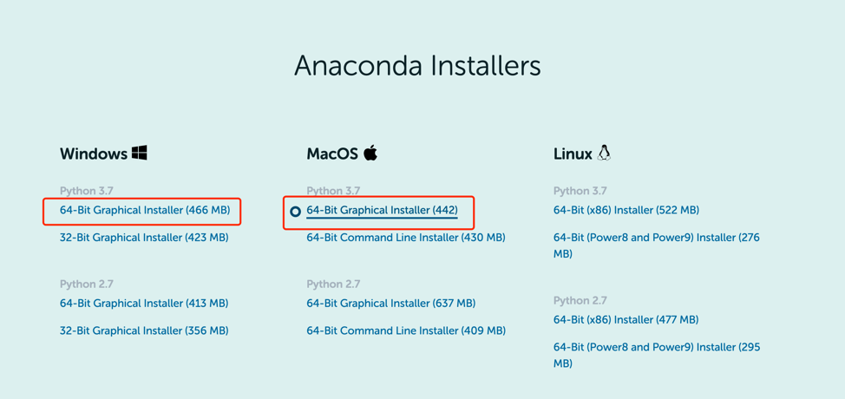

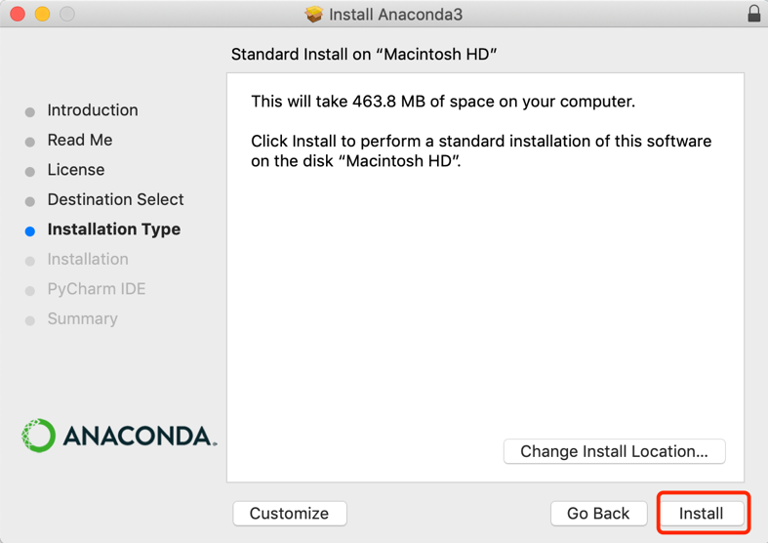

Then open the downloaded package to install Anaconda.

Simply click install and continue, DONE! ↓↓↓



this is the navigator that we’ll use to run the Jupyter notebook for writing python script.

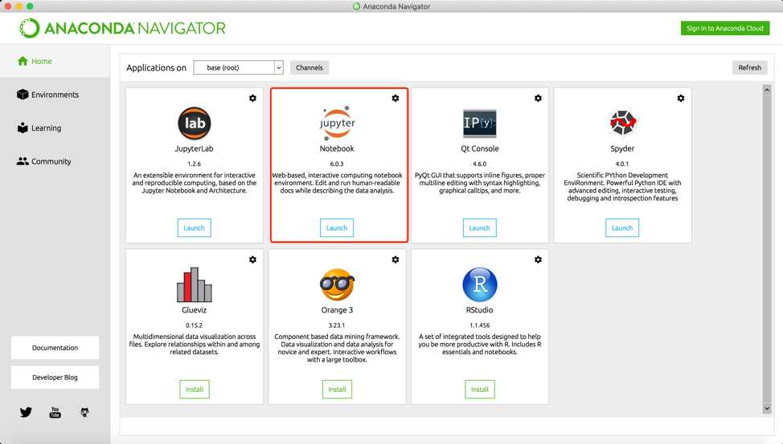

On the home page, Jupyter is available now!

**Problem 2:**

1. Download and install Gutenberg corpus tool to your Jupyter Notebook; Provide **all steps** of installing it, thinks about it as you are making a manual for someone who has no idea on how to do so
2. Download and use source files (provided);
3. Create a table displaying relative frequencies with which “modals” (can, could, may, might, will, would and should) are used in all texts provided (source files)
4. For two modals with the largest span of relative frequencies (most used minus least used), select a text which uses it the most and the text that uses it the least. Compare usage in both texts by examining the concordances of those modals in two texts. Perhaps try to understand how are those words used in different texts;

**Total points: 35**

Put all your steps and screen captures here.

1. the first step is to install and import nltk and then download the Gutenberg corpus from nltk

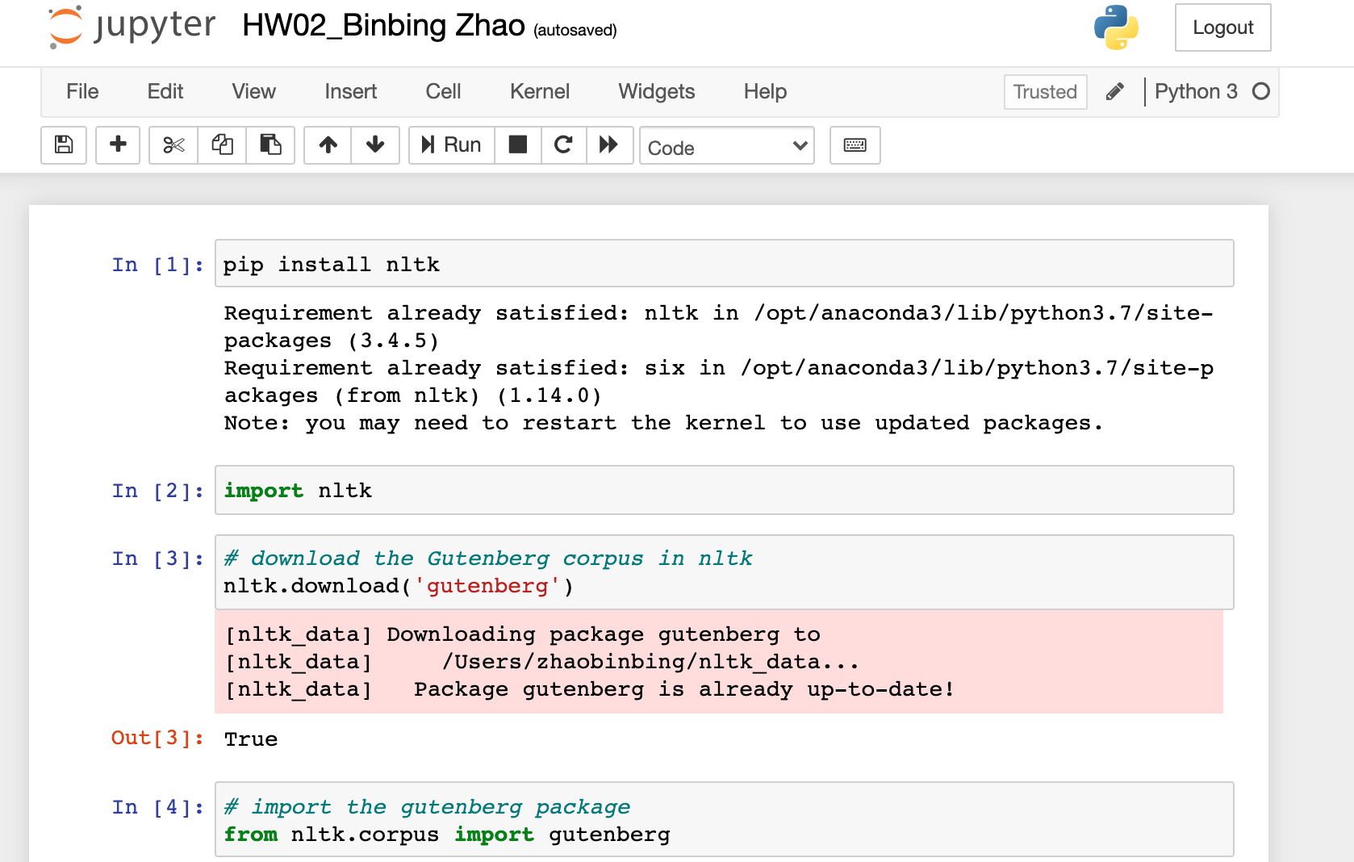

2. Below are the txt files in the package, for example the famous novel “Emma” by Jane Austen, and the paly “hamlet” by William Shakespeare.

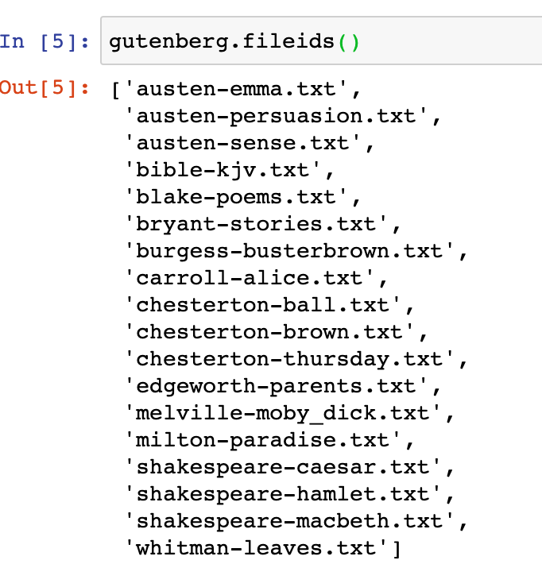 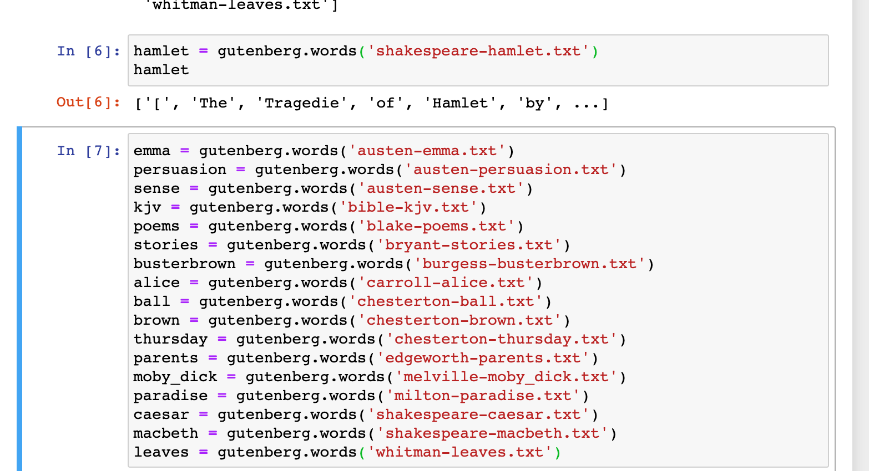

Let’s take a look at the text file and define dataset.

Count words included in each text:

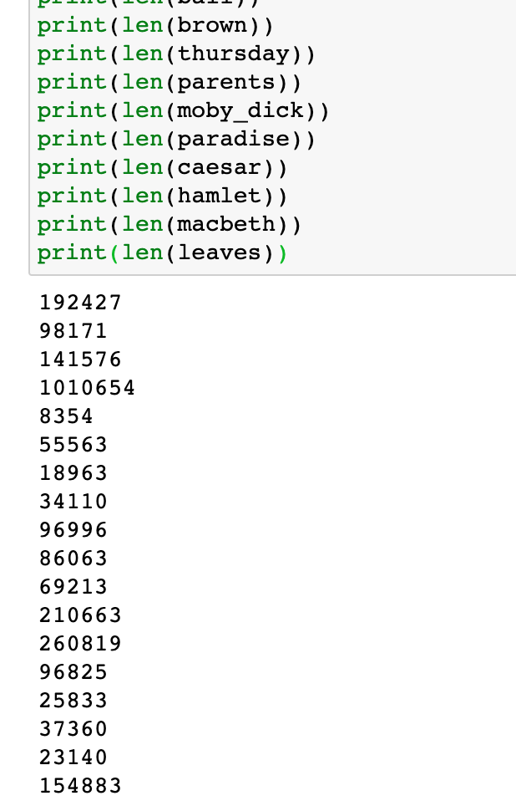

Example: to find out the count of each Modals from “Hamelet”

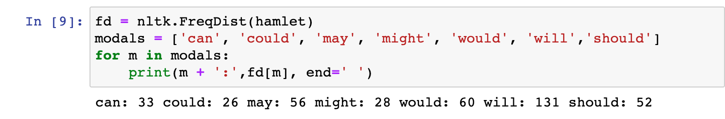

Then, to count modals in all text files:

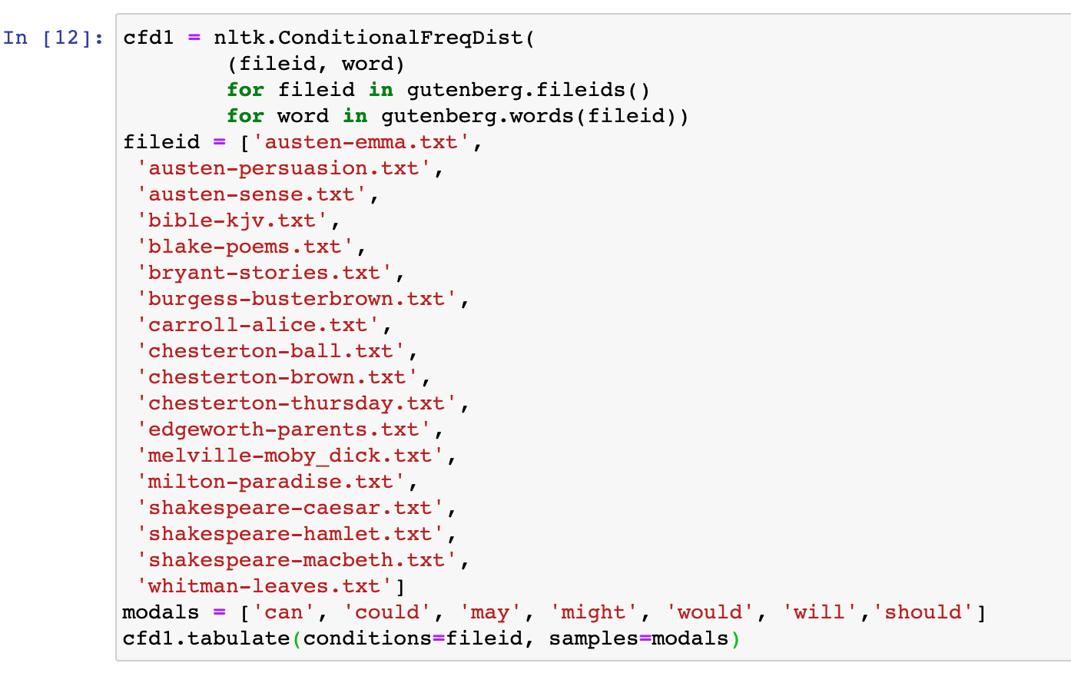 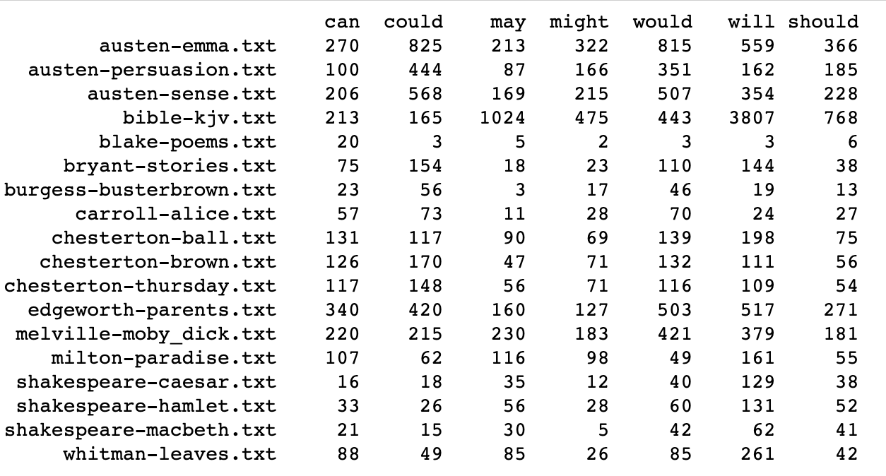

And create data frame:

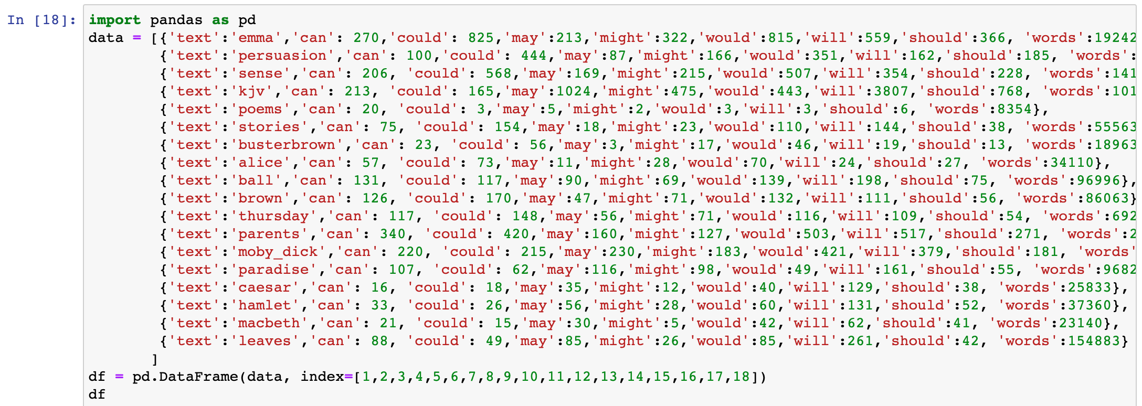

Then, build the relative frequencies table for all the modals in different text

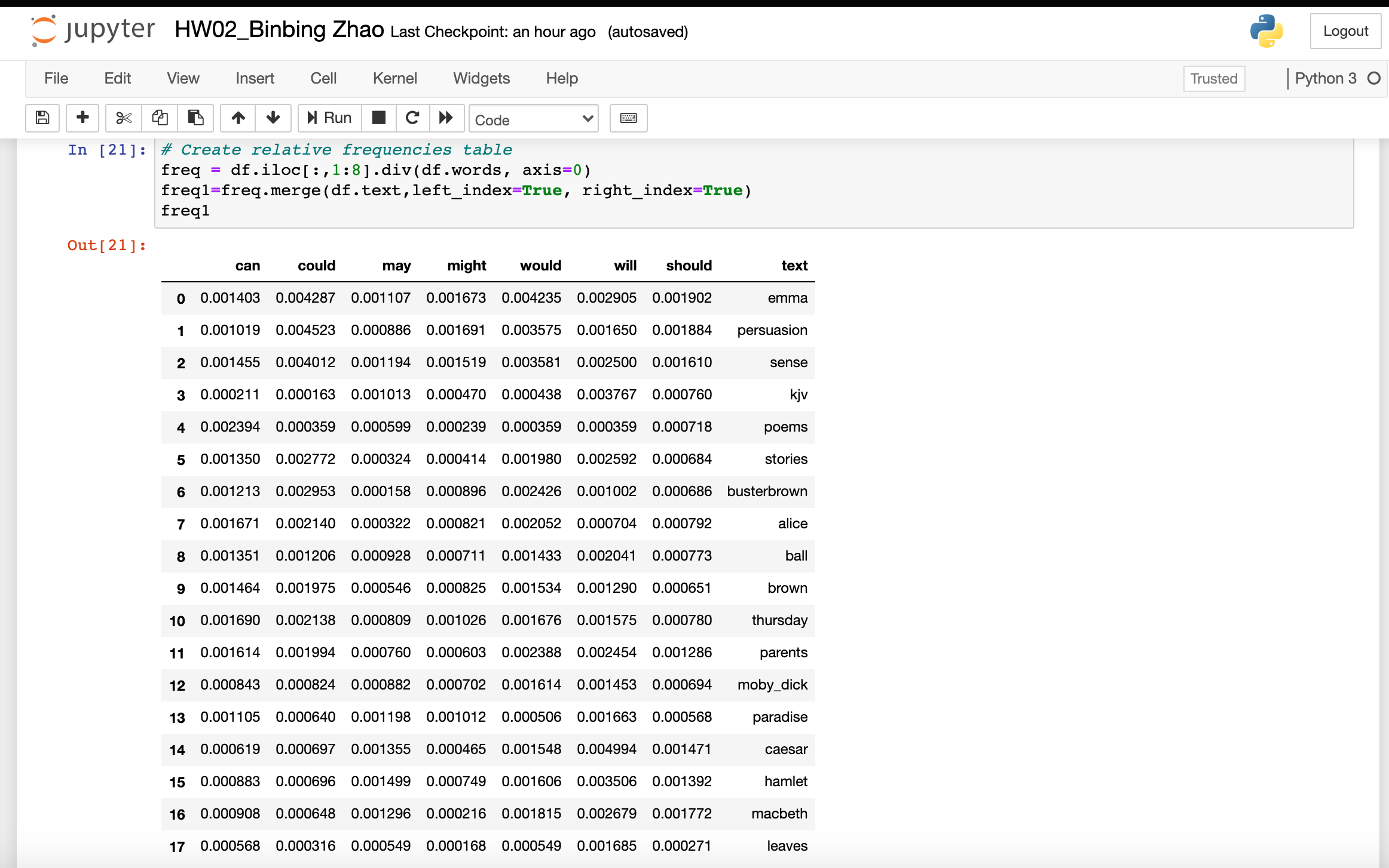

Make a bar plot by seaborn to see which modal was most used and which was least used in general.

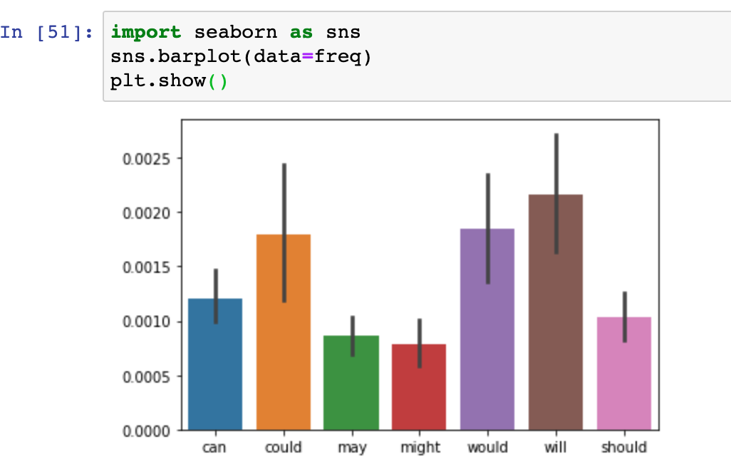

We can see “will” was the most frequently used modal and “might” was the least used modal among all the Gutenberg text from the nltk package.

Let’s take a deeper look into specific text words frequencies:

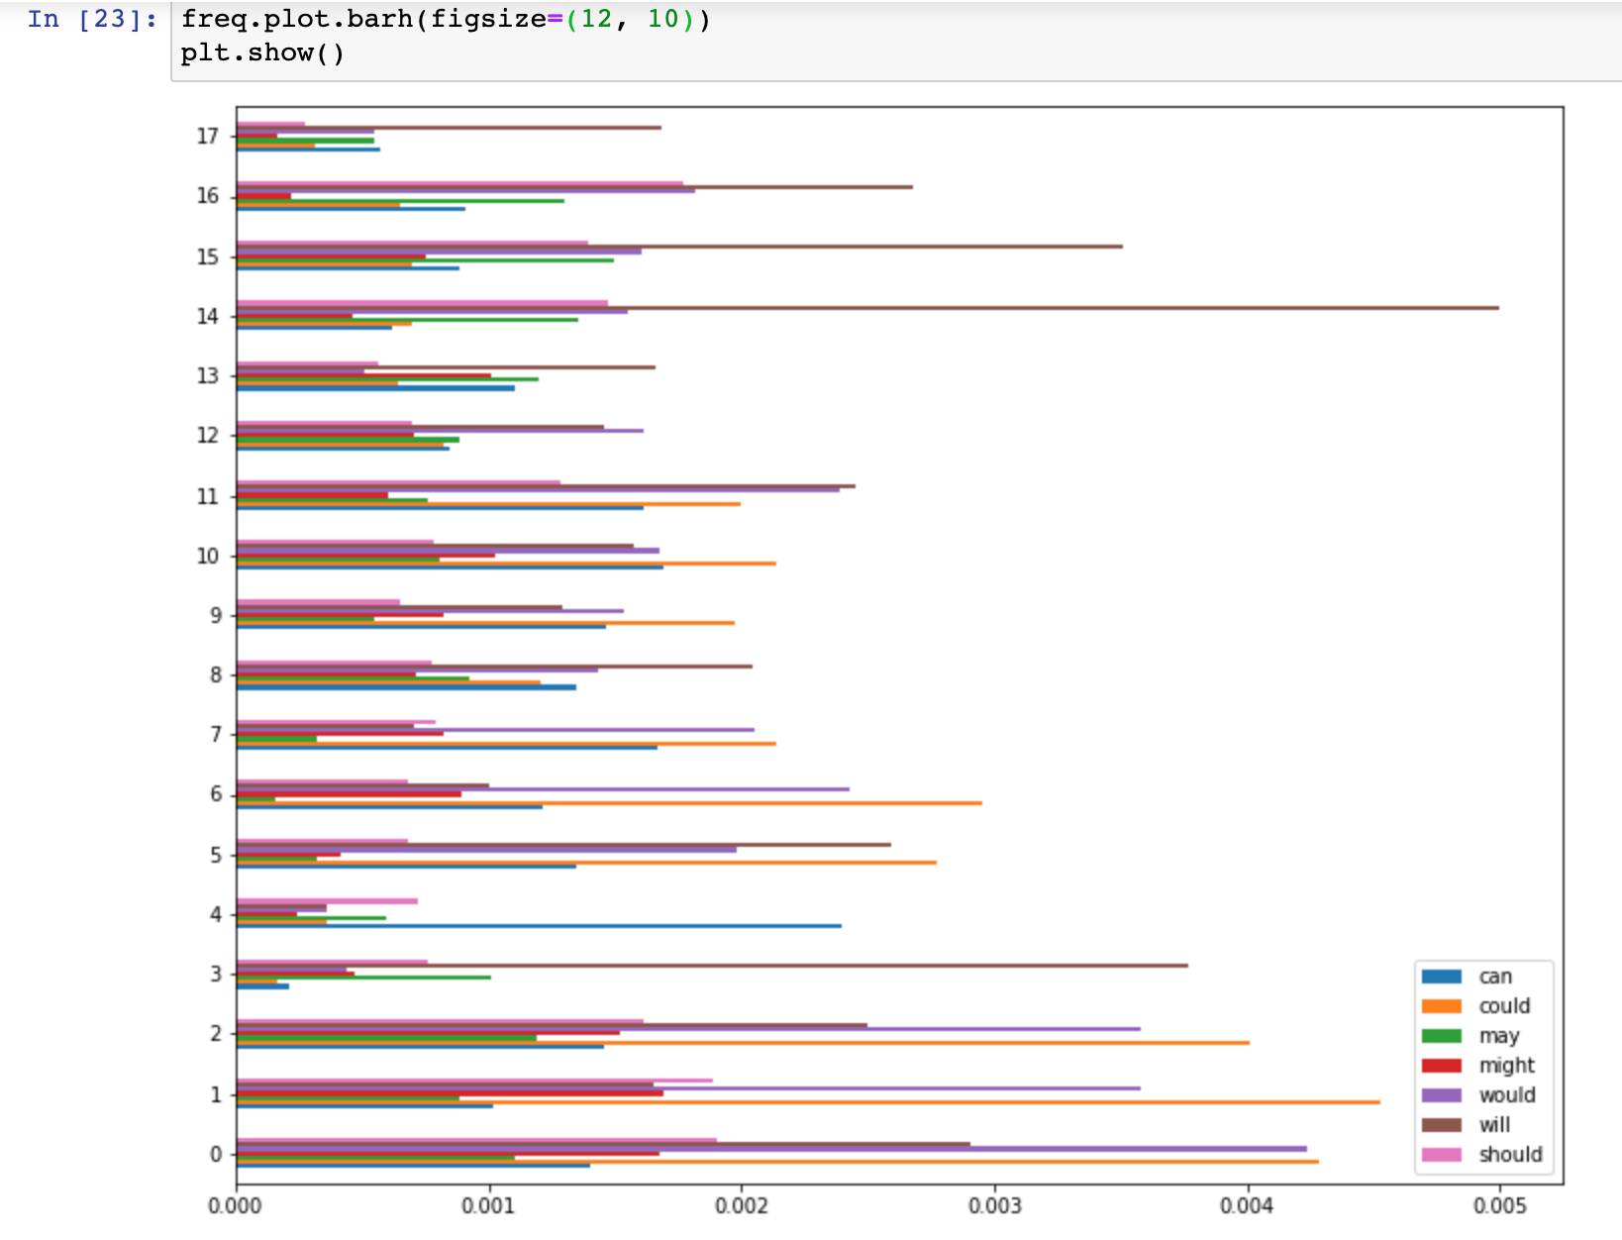

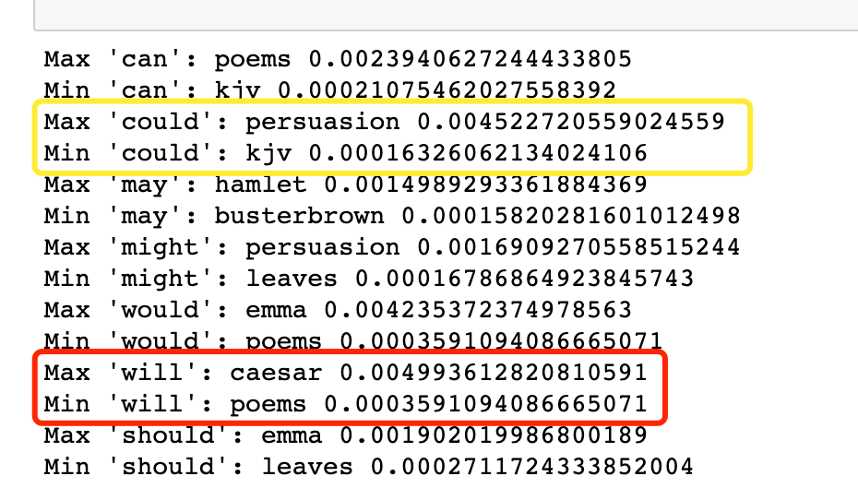

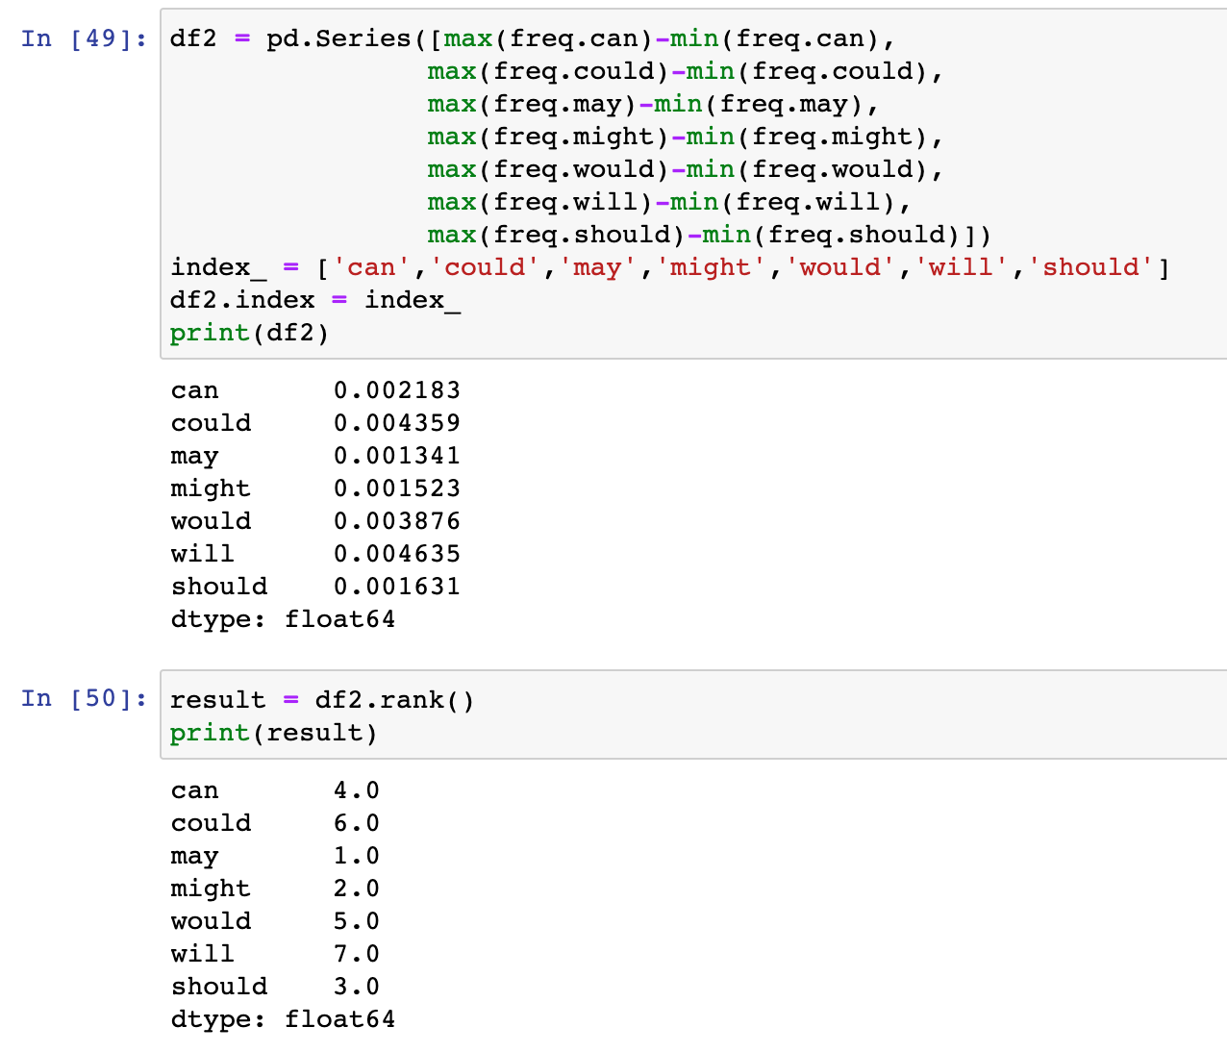

Modals with the largest span of relative frequencies:

**1. “will”**

Max: Shakespeare-caesar

Min: blake-poems

**2. “could”**

Max: austen-persuasion

Min: bible-kjv

Therefore, the modal **“will”** will be examined in Caesar (used “will” the most) and Poems (used “will” the least) texts.

If I use the concordance tool directly there is an error occurred ↓

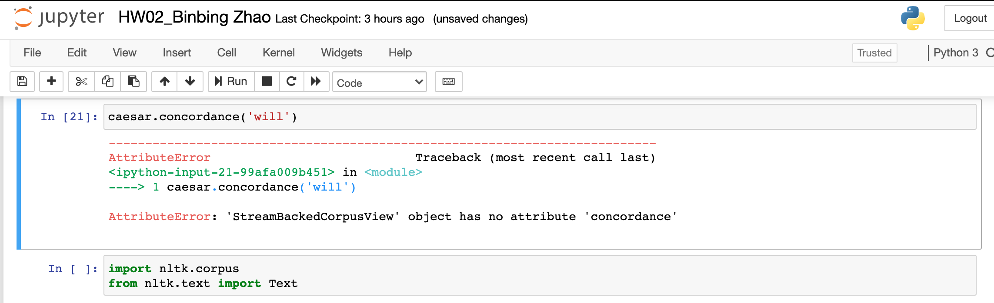

Instead, I imported nltk.text package to use the “concordance” as below:

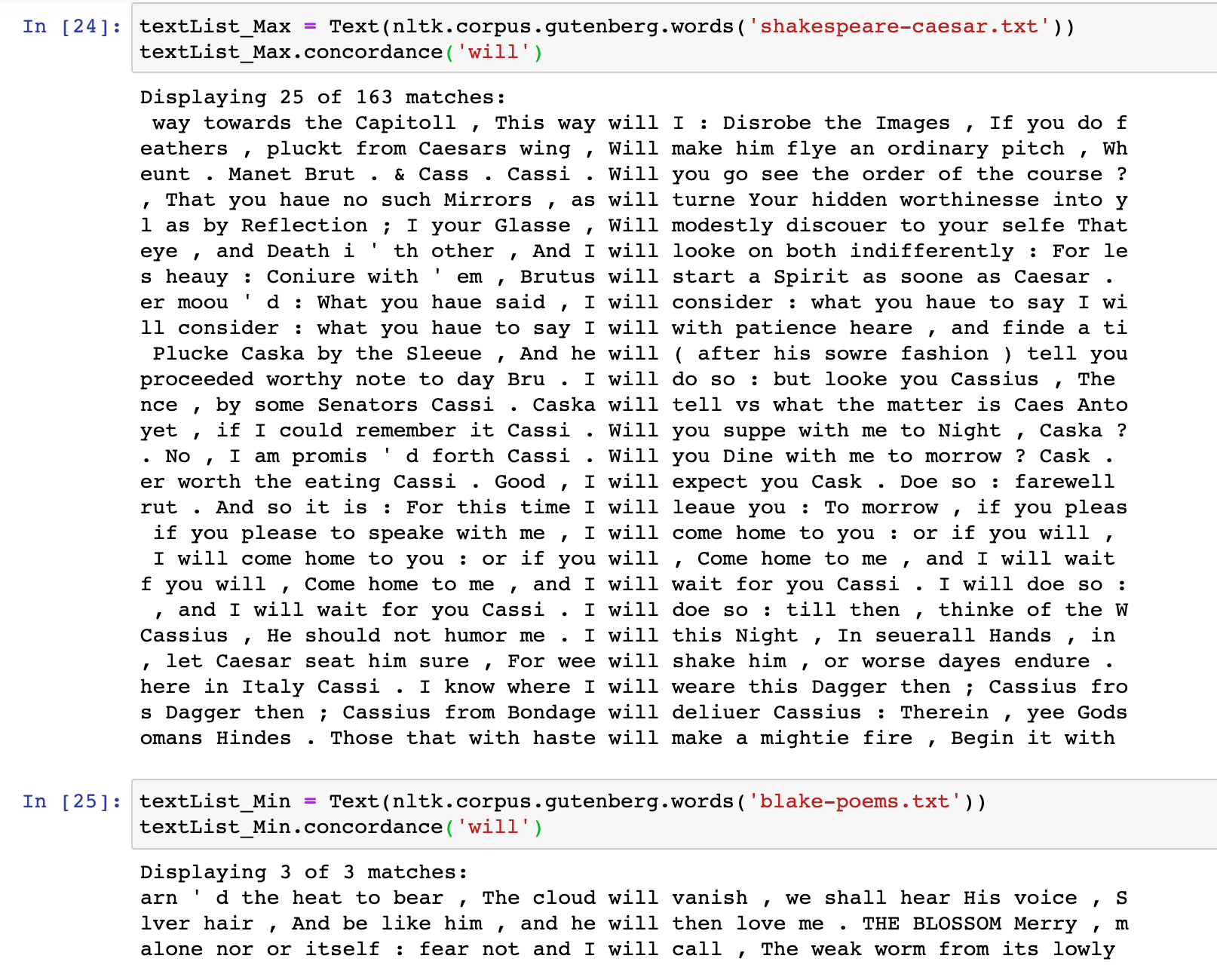

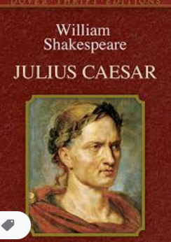 

*(The Death of Julius Caesar by Vincenzo Camuccini, 1798)*

Julius Caesar is a tragedy like many of Shakespeare’s other plays. This play is partly a history and involves civil war and the politics of Ancient Rome.

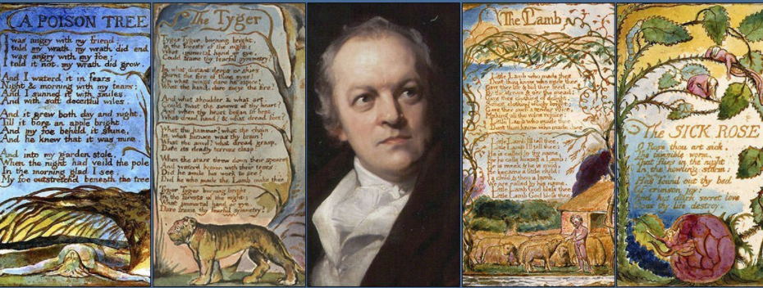

*(Poems by William Blake)*

William Blake was a poet, painter, and printmaker from England, who is considered as the visual arts of the Romantic Age.

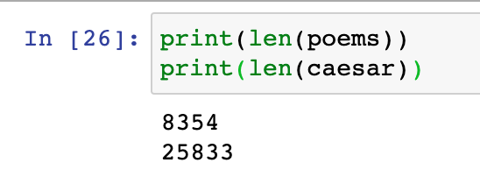

**Comparisons**:

1. Poetry has few words in total than plays.
2. Shakespeare uses modal auxiliary verbs like “may”, “will”, “should”, etc. creatively in his plays to ground situations in potentiality. “Potential action” in dramas as in life assessing possibilities, and disclosing fears or desires, indicating obligations or conflicts. By using “modals”, especially “will”, audiences or readers will assess and respond to how all of different inclinations condition.

**Problem 3:**

1. In the Inaugural corpus identify 10 most frequently used words longer than 7 characters;
2. Which one of those has the largest number of synonyms?
3. List all synonyms for those 10 words. Which one of those 10 words has the largest number of hyponyms?
4. List all hyponyms of those 10 most frequently used “long” words.

**Total points: 35**

**Inaugural Address Corpus**

Frequency Distributions

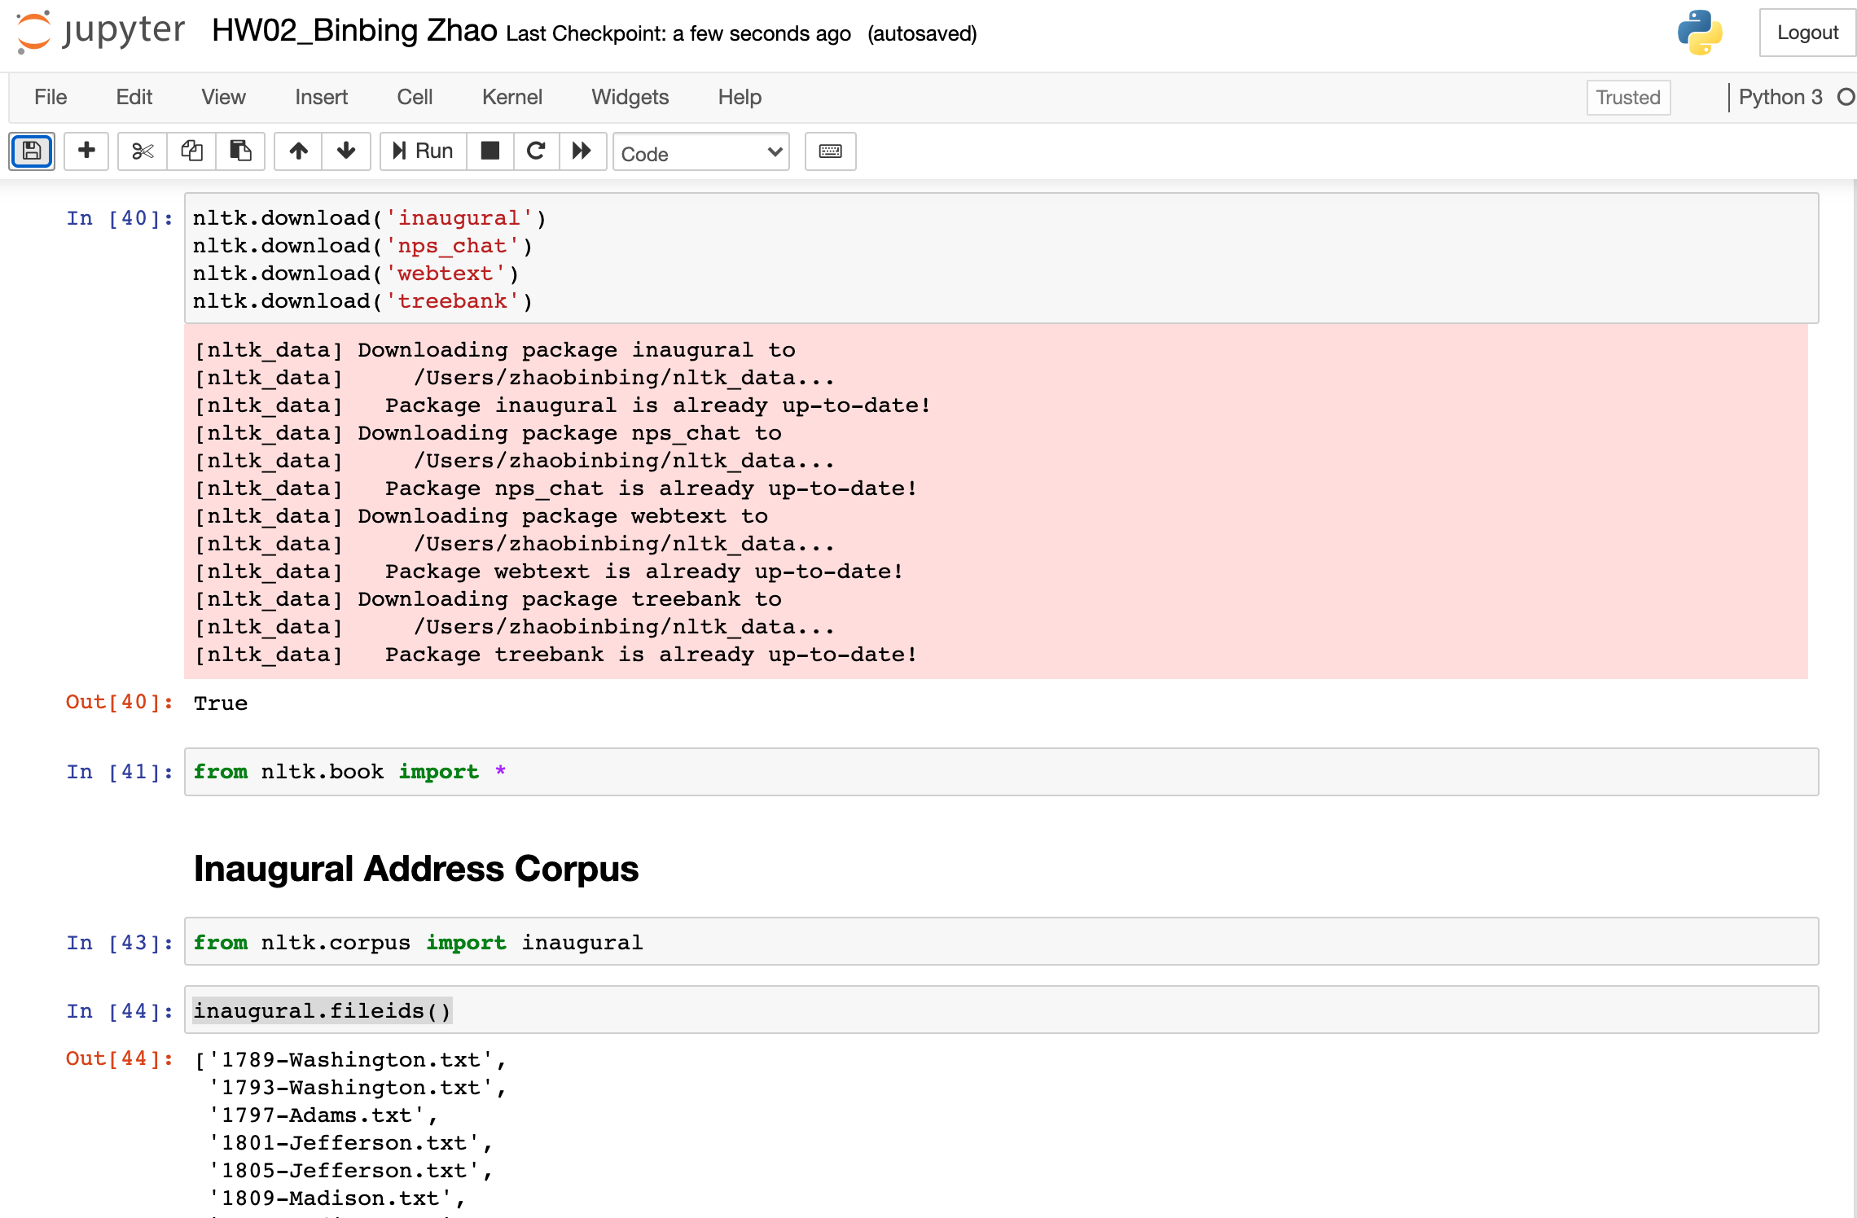

The first step is to import the inaugural from nltk.corpus and to check included txt files.

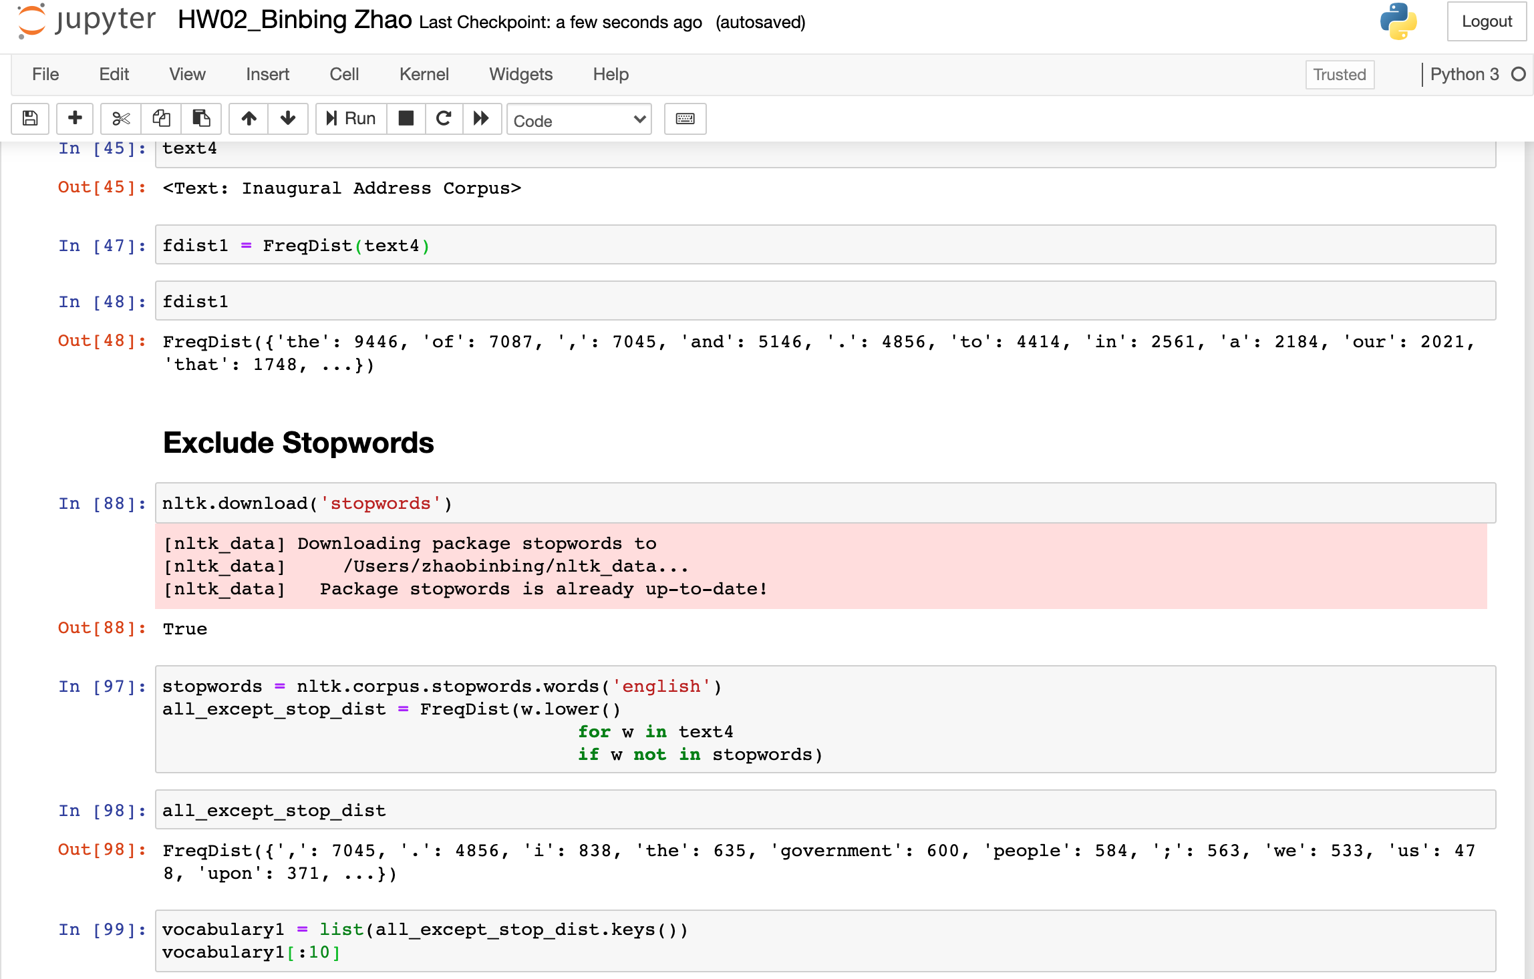

Exercise: try to exclude the stopwords

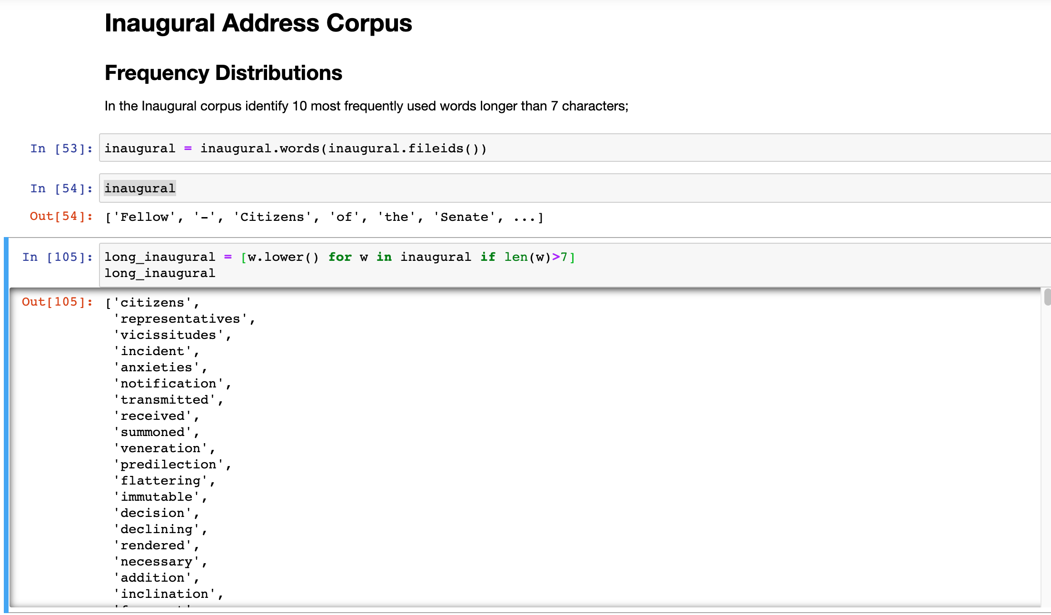

Define the inaugural data and filter words longer than 7 characters

To find out the top 10 most frequently used words (> 7 characters):

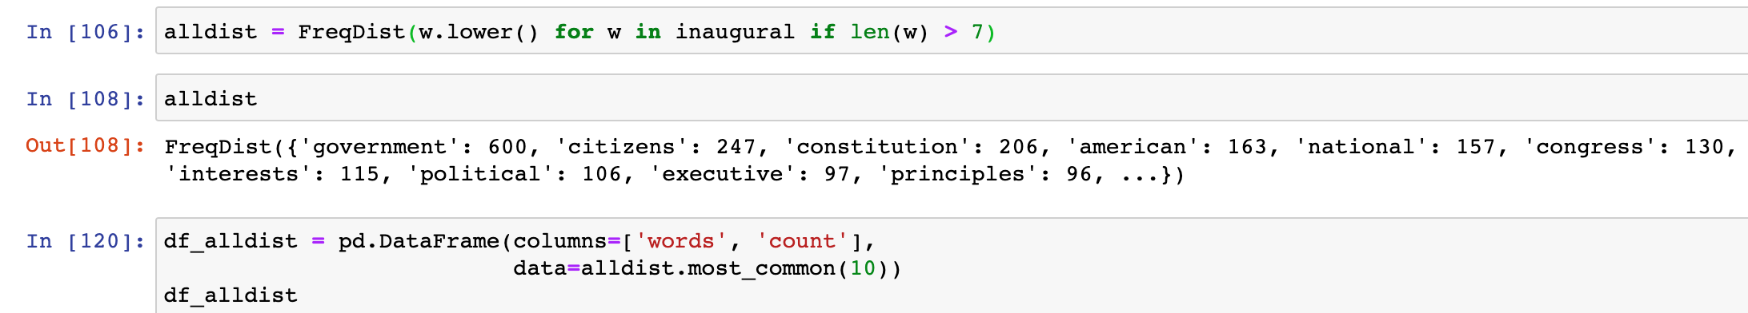

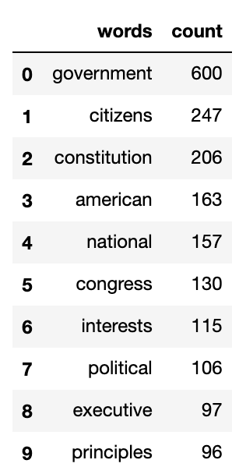

As shown above, the most frequent word is “government” (600 times), follows by “citizens” and “constitution”.

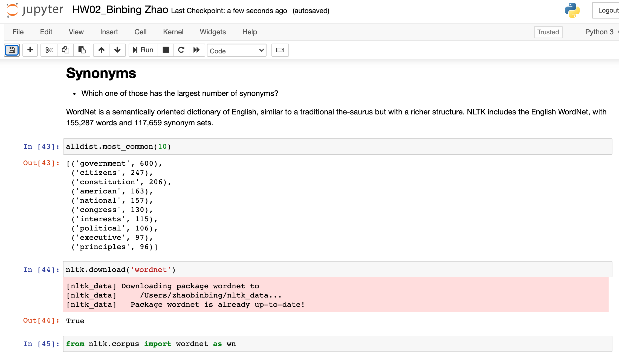

Fristly, download the ‘wordnet’ package and import wordnet

Try to chek out example word “government” for its synonyms

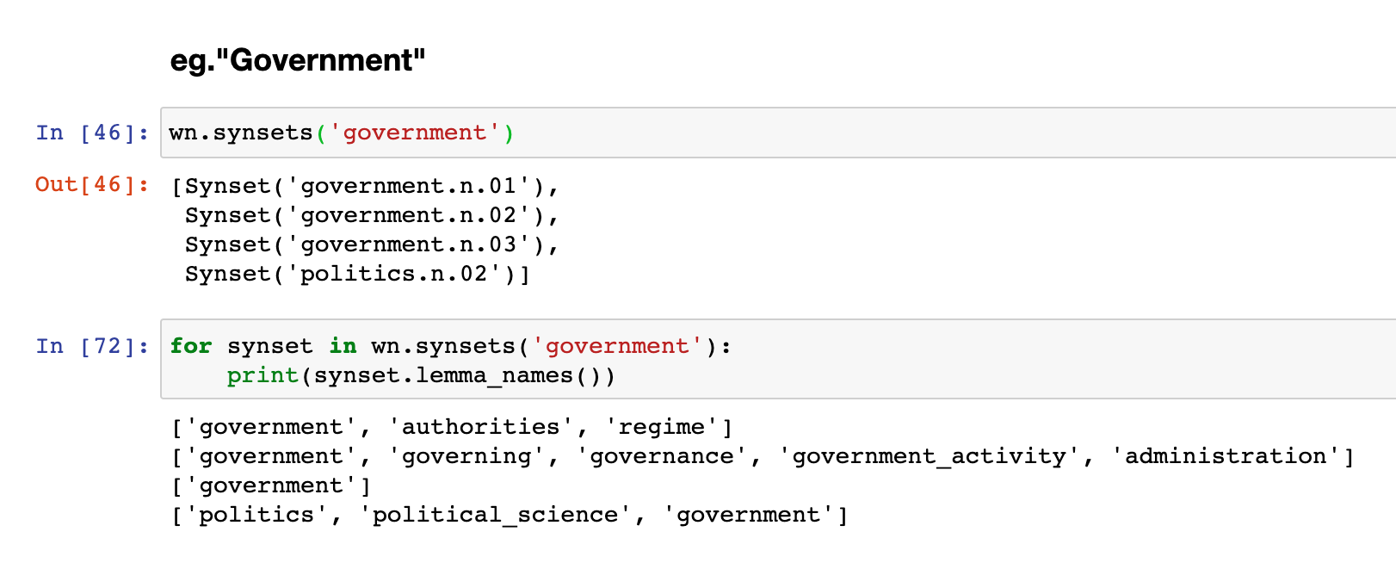

List all the synonyms for those top 10 words: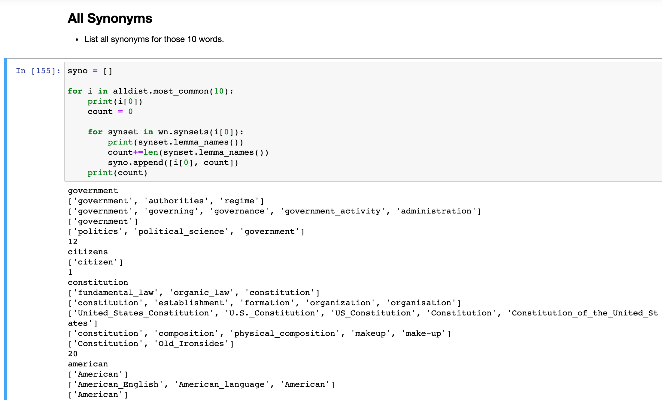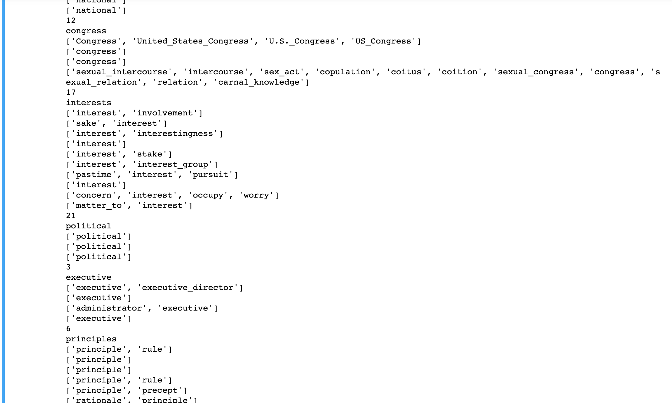

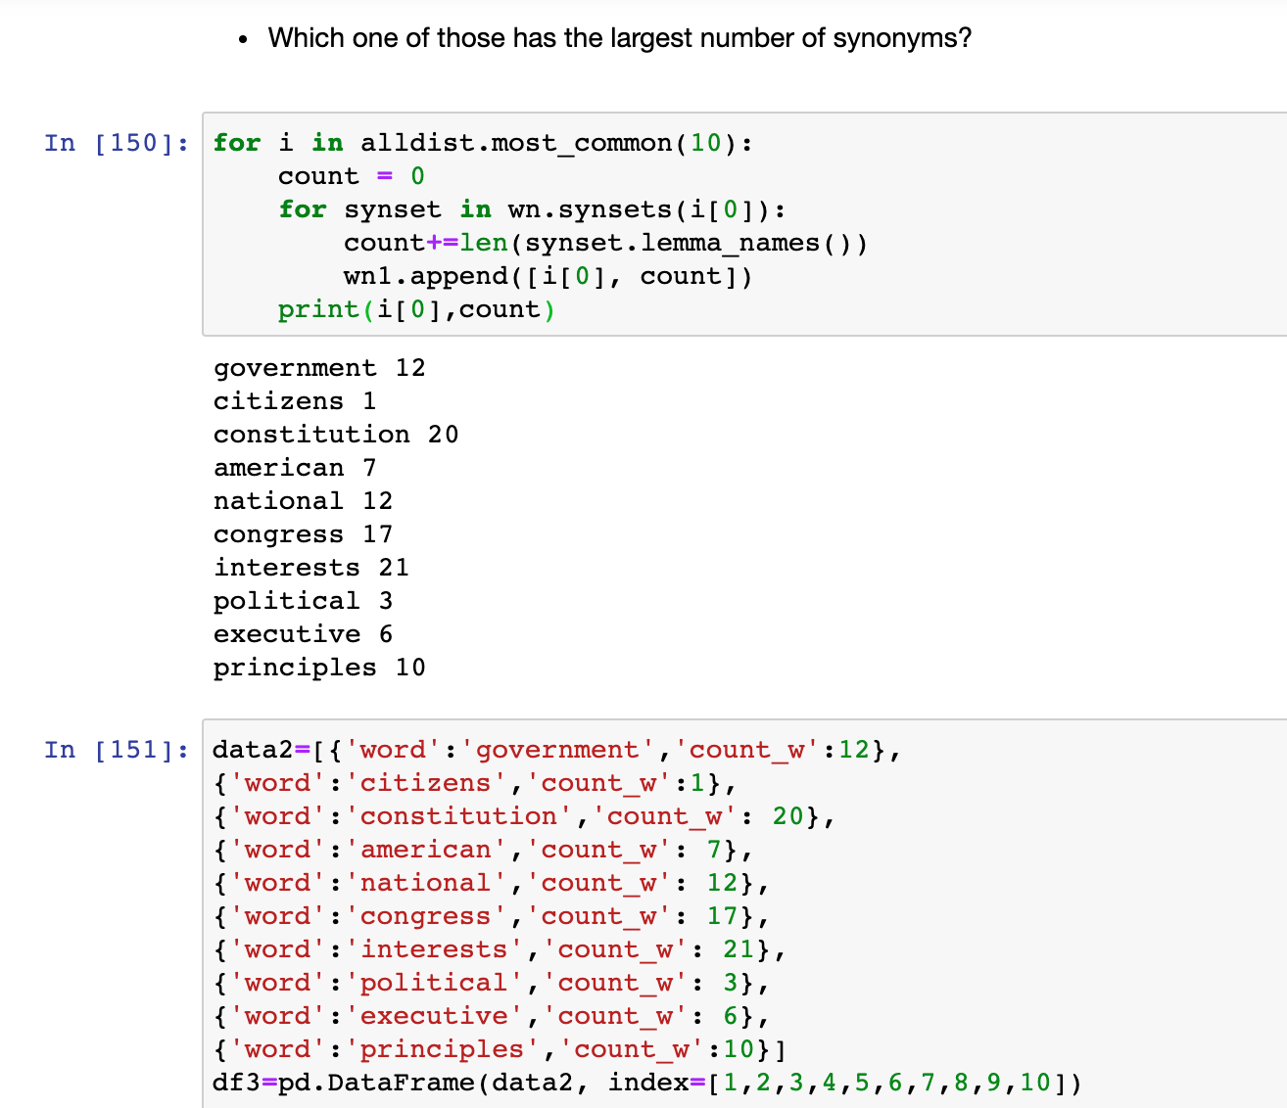

Therefore we can conclude the word with the largest number of synonyms is “interests” with 21 synonyms. “citizens” has the least words.

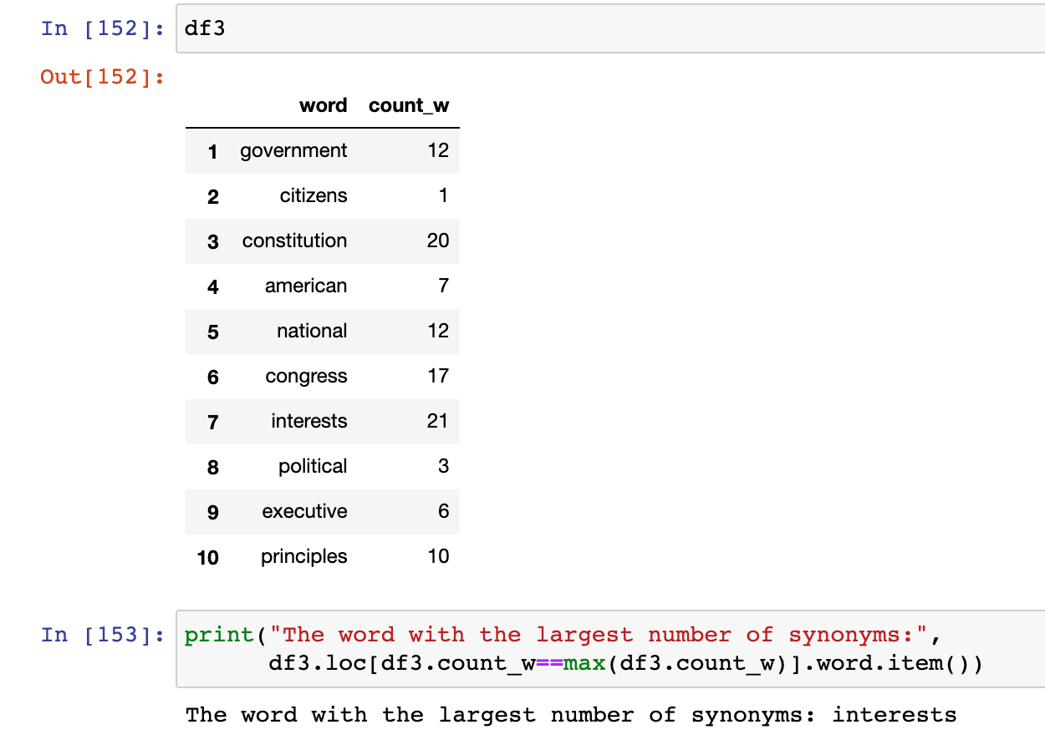

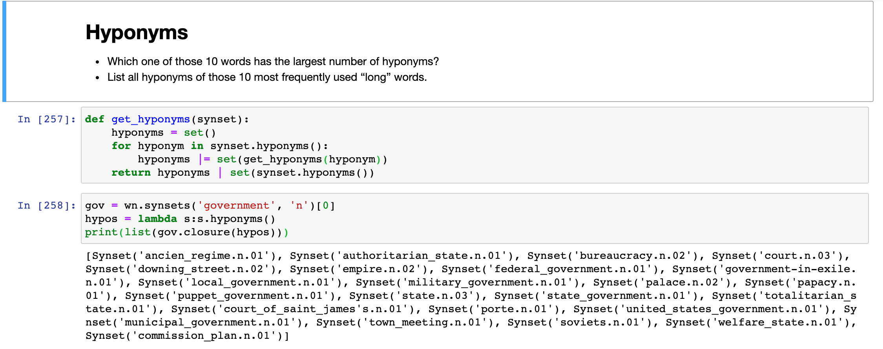 Similarly, we check an example word “government” for its hyponyms lists

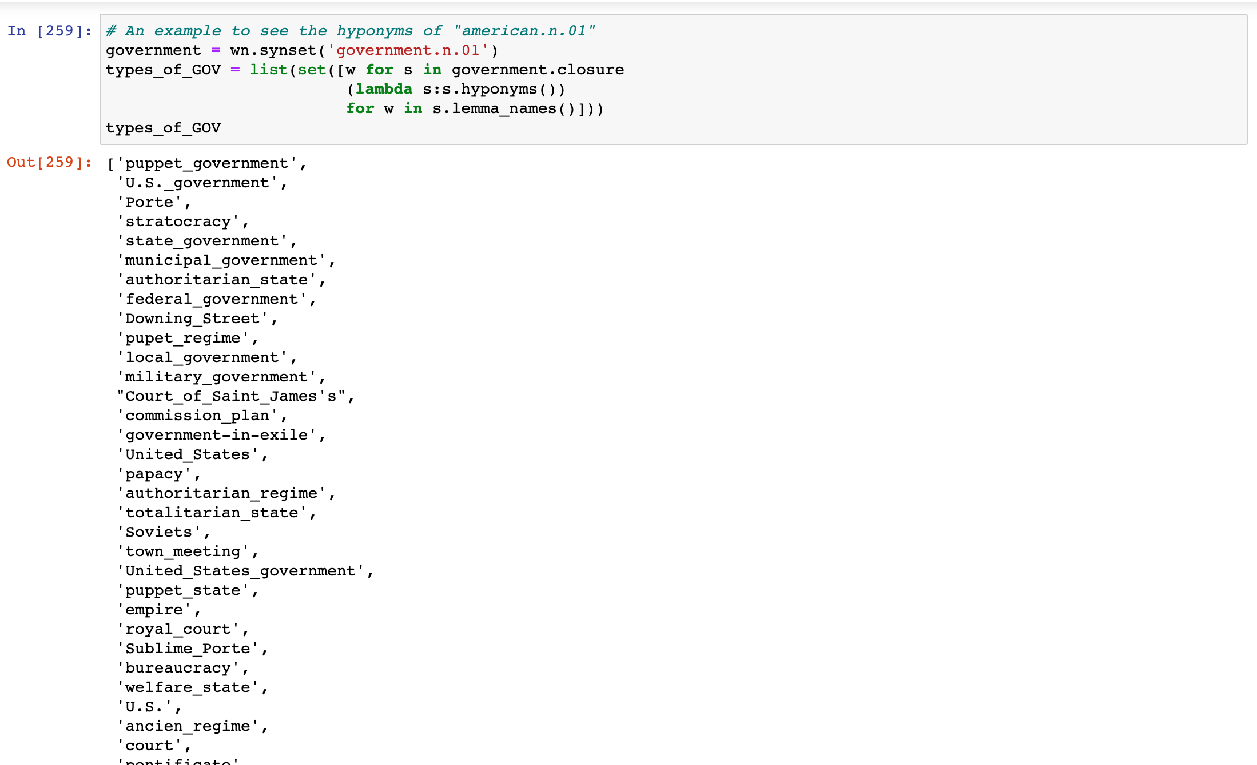

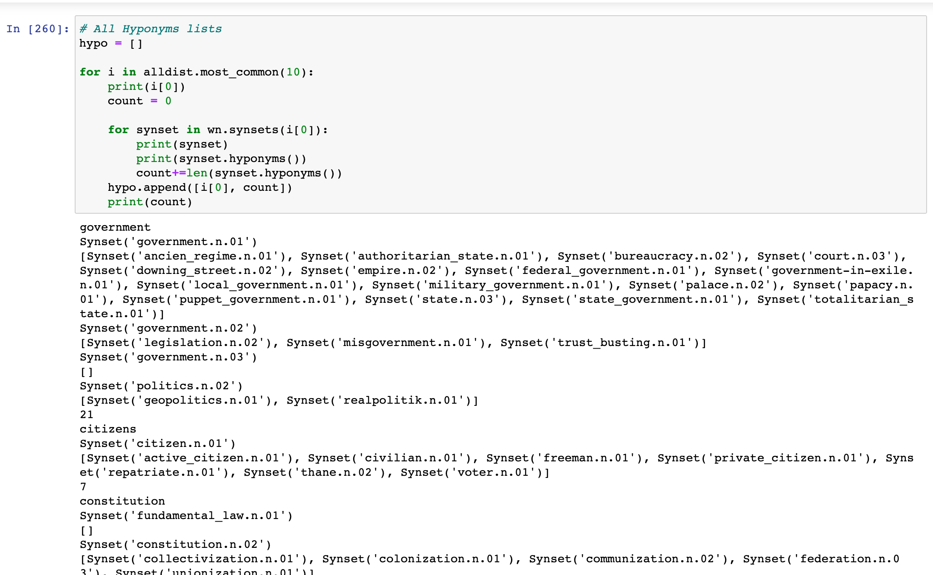

**List all the hyponyms lists for all those ten words by using Recursion. ↑**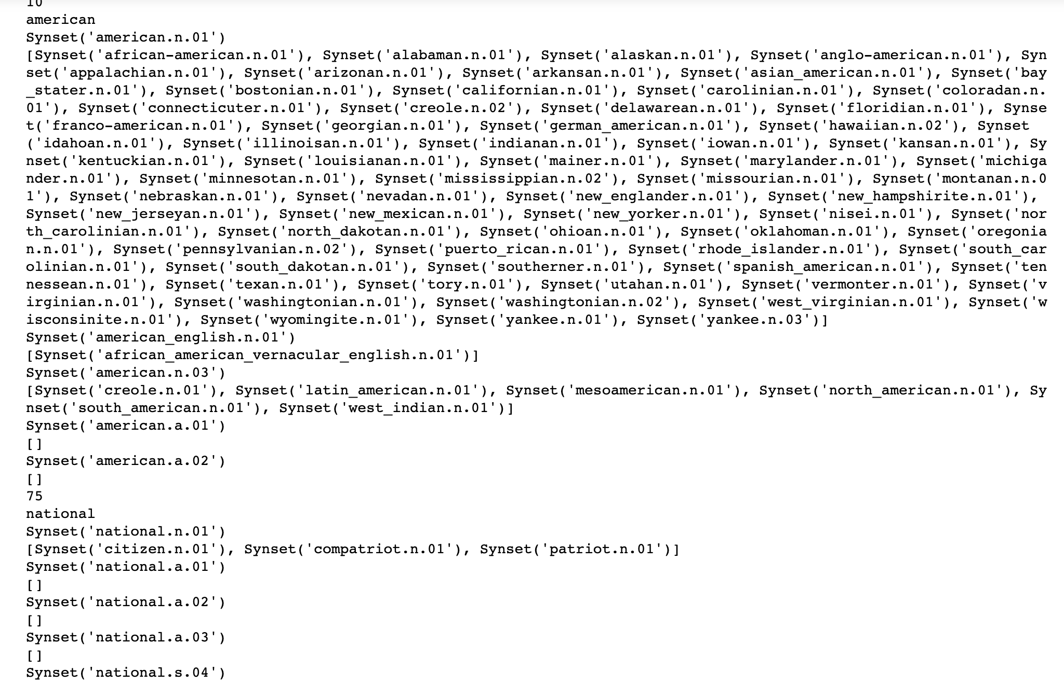

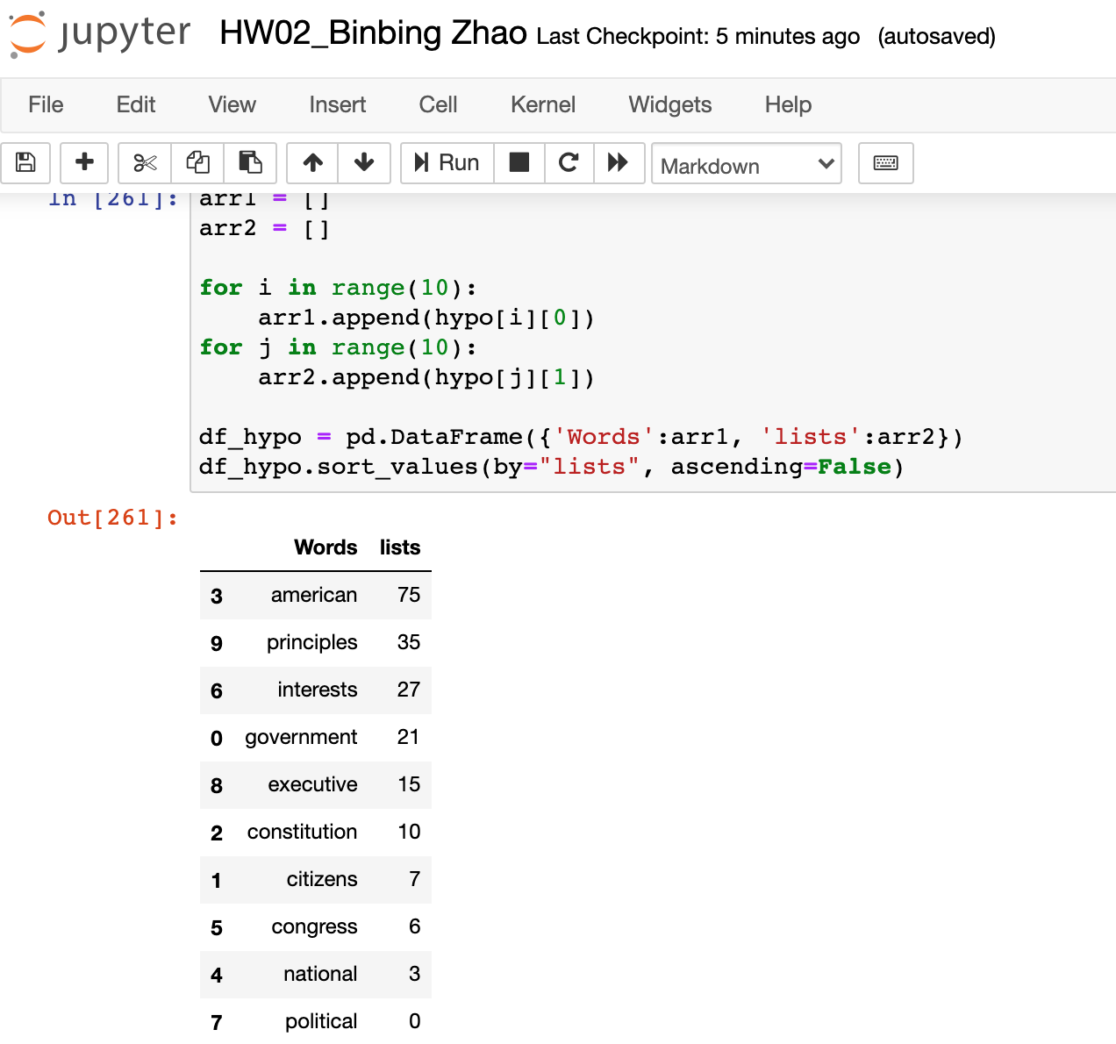

So, “american” has 75 hyponyms lists which make sense because there are many different types of noun for americans in different states or locations. The word with least hyponyms is “political”, because it is a more rigorous word.

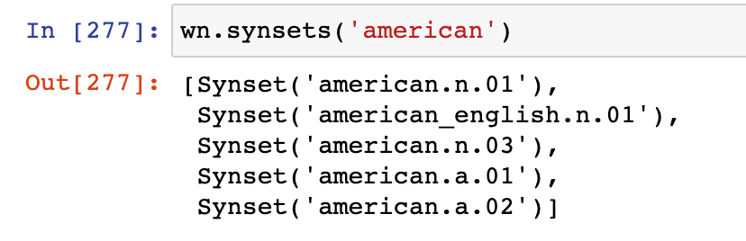

We can see there are five synsets for ‘american’

Let’s check out all the hyponyms words in each sysnset:

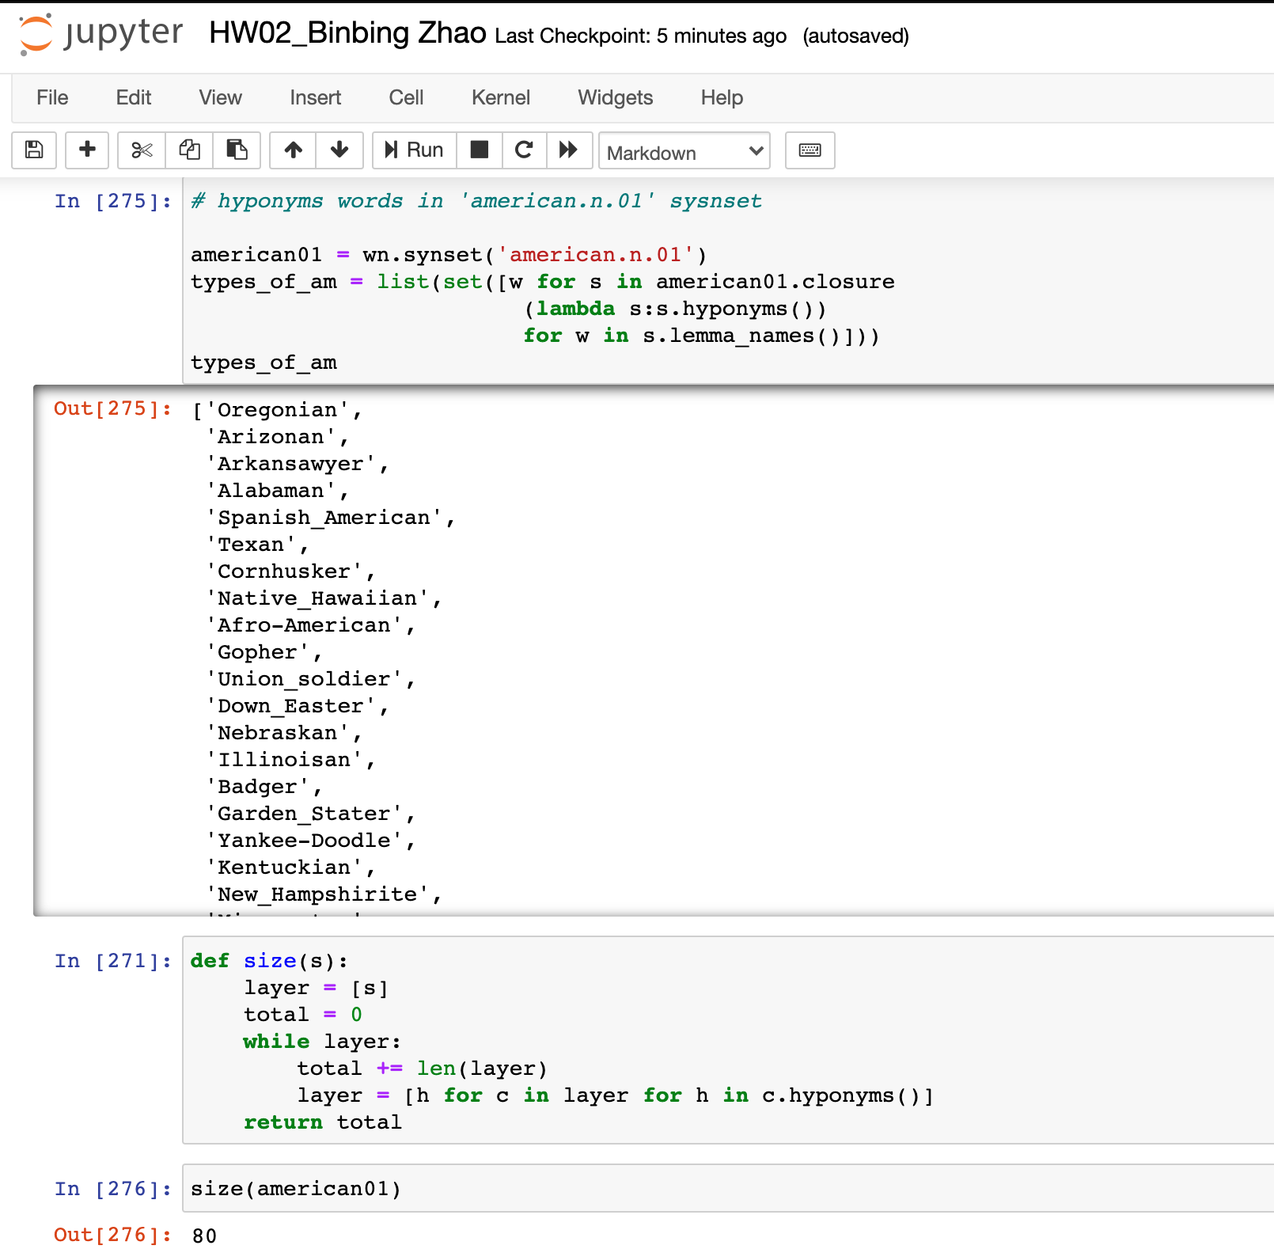

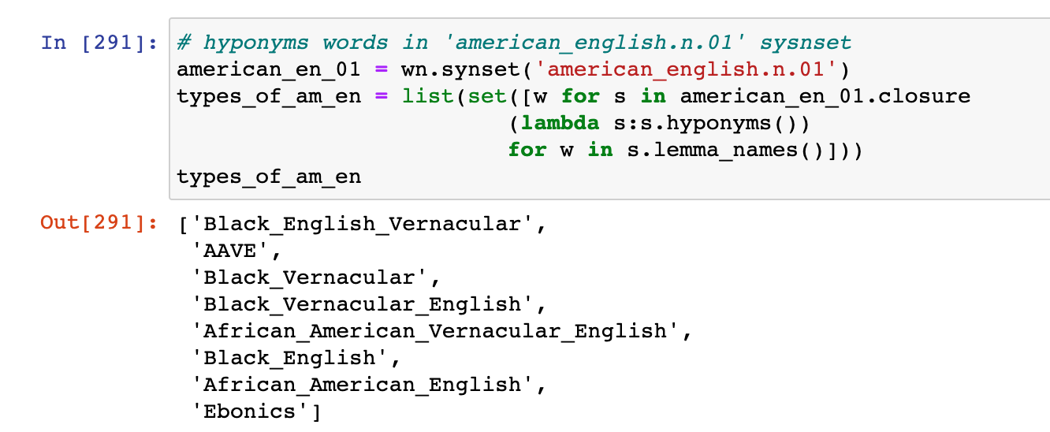 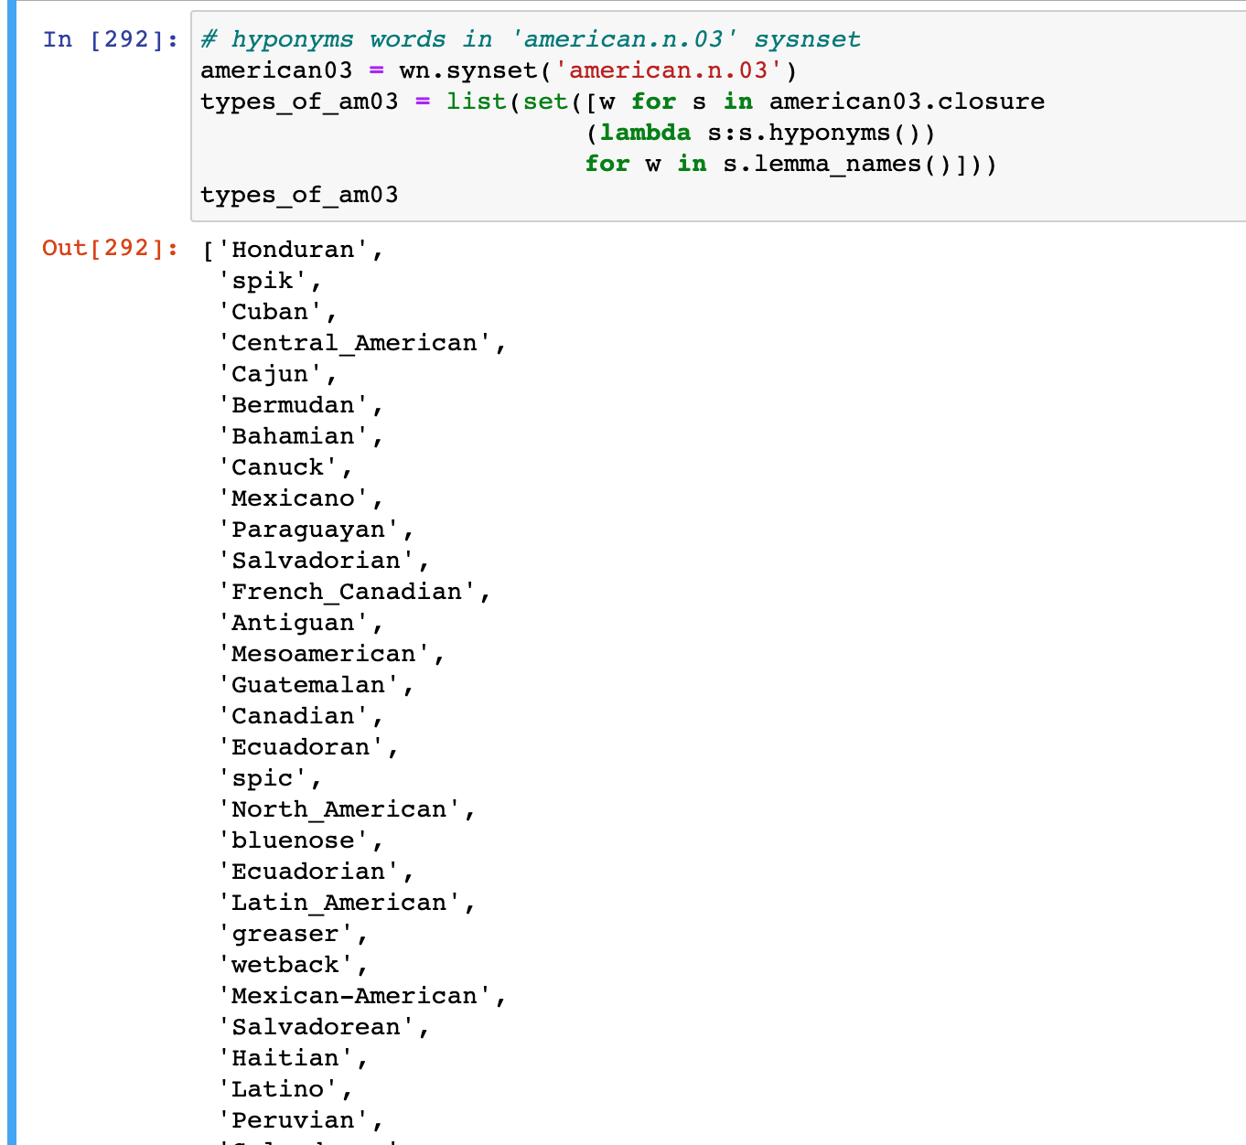 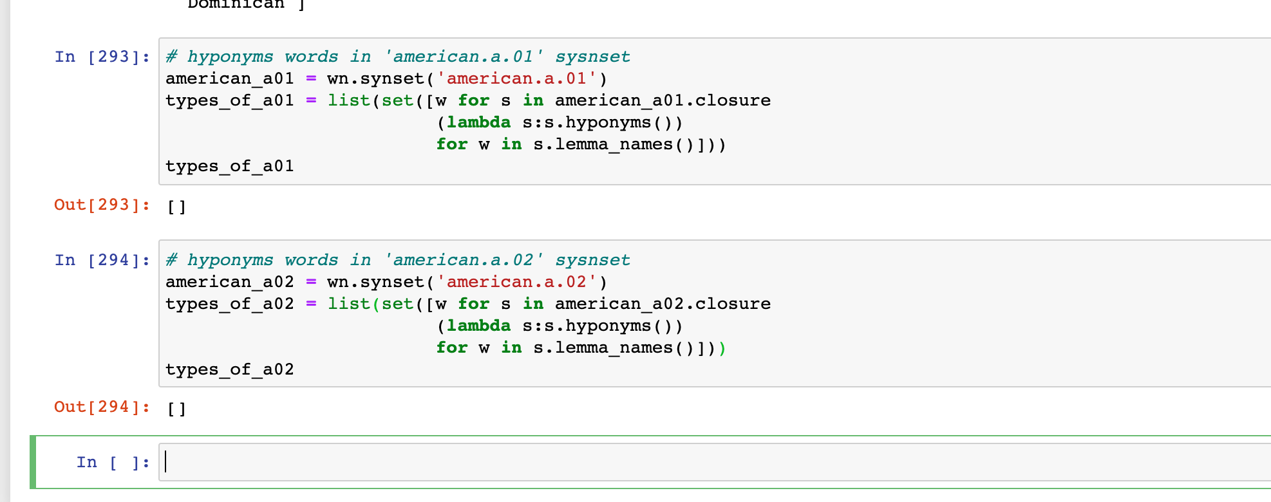

**Please NOTE!!!**

**You literature, as well as a big help, for this assignment are chapters 1 and 2 of Natural Language Processing with Python book by Steven Bird et al.**

**Reference**

Bird, Steven, Klein, Ewan, Loper, Edward, and Safari, an O'Reilly Media Company. Natural Language Processing with Python (2009). Web.

Magnusson, L. (2015). Shakespeare and the Language of Possibility. Retrieved from <https://folgerpedia.folger.edu/mediawiki/media/images_pedia_folgerpedia_mw/1/17/2015BdayLecture_Magnusson.pdf>

------------------------------------------------------------------------------------------------------------